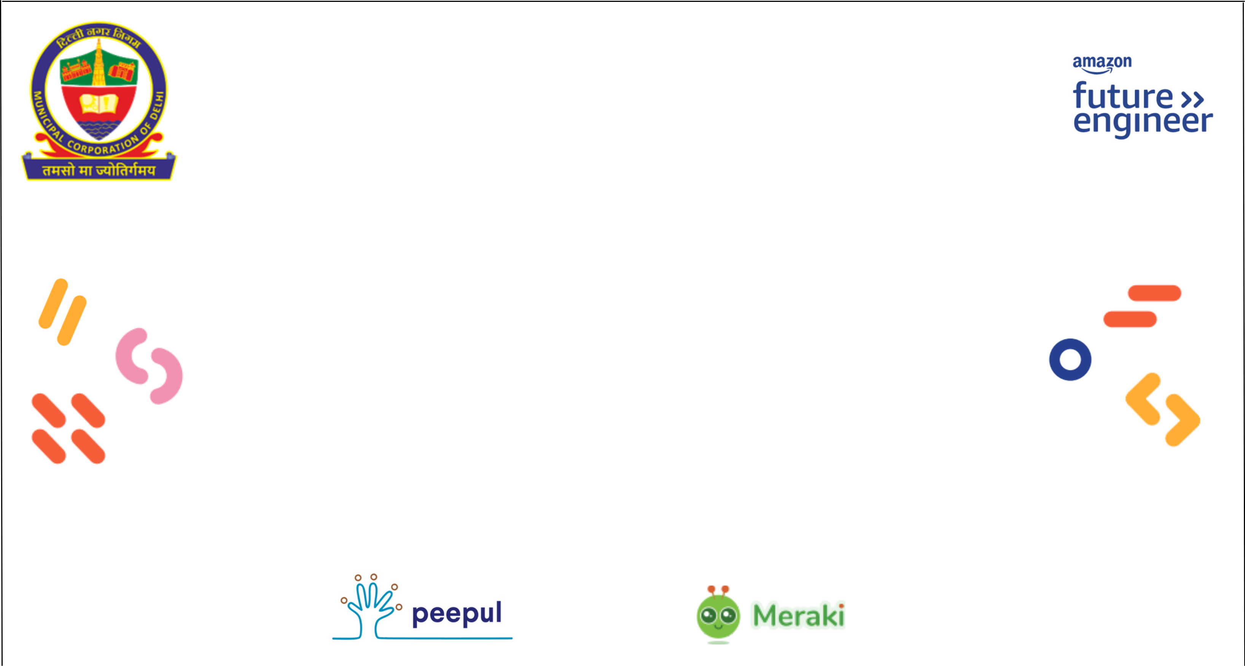

**PEEPUL in collaboration with AMAZON INDIA**

**This Certificate of Completion is awarded to**

**{Name}**

from {School} school, for successfully completing Online Capacity Building Training on Meraki

in collaboration with

